**[to be integrated into Architecture Documentation.docx as subchapter 4.3.2]**

### Frontend

The frontend runs within the user’s browser. It implements both the MVC pattern and SOA. The following figure gives an overview of the different components of the frontend and its layers.

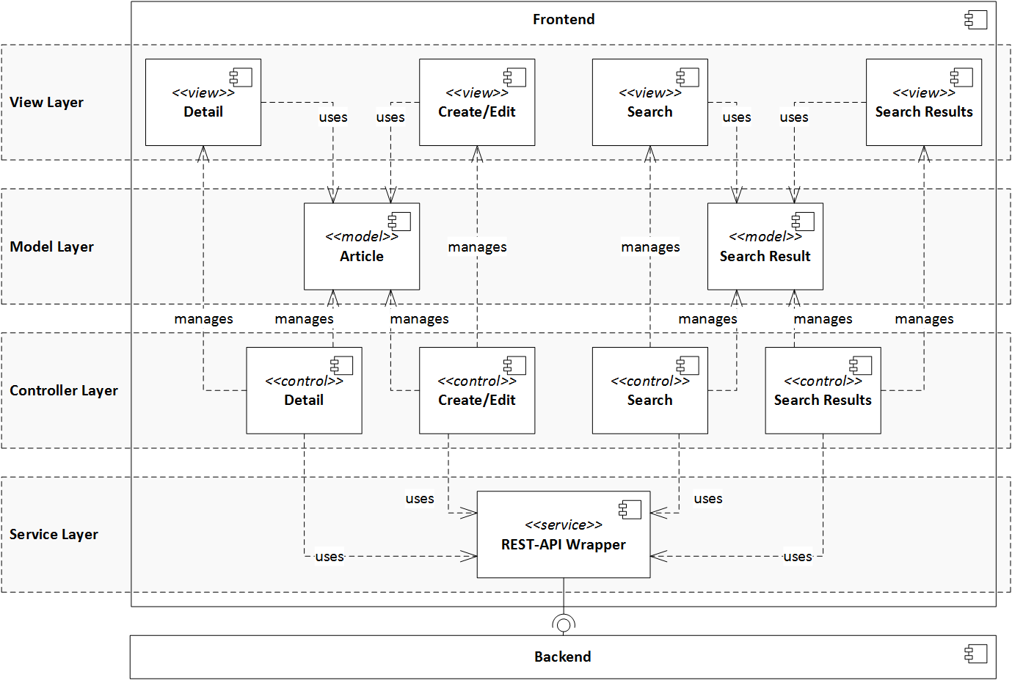

#### Service Layer

The fundamental part of the frontend is its service layer. It connects the frontend to the backend by wrapping the backend’s REST interface within a service available globally for all controllers. This way all alike calls to the backend are routed through the same method, offering the opportunity to integrate caches, interceptors and making changes in the server API transparent for all frontend components except the service layer component.

#### Controller Layer

Business logic of the frontend application is implemented within the controller layer. Here a controller is defined for each view handling user interactions by manipulating respective models and forwarding calls to the backend to the service layer.

#### Model Layer

The model layer stores the data presented and worked on in the frontend. Different models are loaded by controllers using the backend API service from the service layer. Data from these models are presented to the user in the view layer and is manipulated by controllers in the controller layer.

#### View Layer

The view layer delineates the interface of the frontend application towards the user. It is rendered by the browser and has its functionality handled by its respective controller from the control layer. Information shown within a view is based upon its respective model from the model layer.